John Herron

EE 2310

Semester Design Project

(ADD = 0x4)

John Herron

EE 2310

Semester Design Project

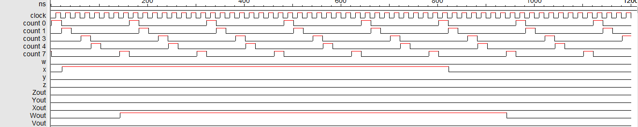

John Herron

EE 2310

Semester Design Project

(AND = 0x7)

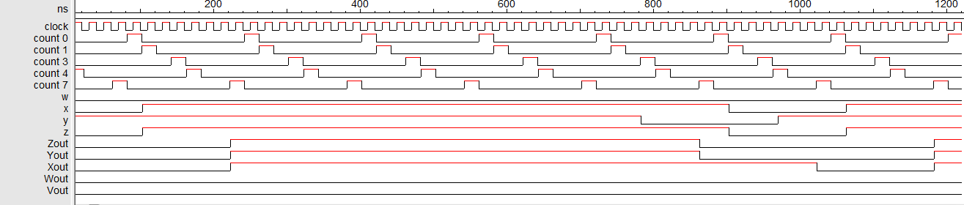

John Herron

EE 2310

Semester Design Project

John Herron

EE 2310

Semester Design Project

(OR = 0xa)

John Herron

EE 2310

Semester Design Project

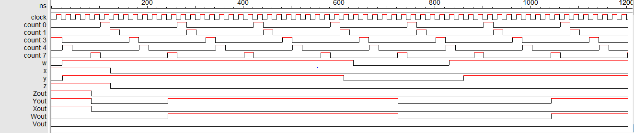

John Herron

EE 2310

Semester Design Project

(NOT = 0xe)

John Herron

EE 2310

Semester Design Project

